PROG8060  
PROject Proposal

2020-02-03

# Group 7

# ALISHA PATEL (8226615)

# PRIT PATEL (8568891)

# PARAS AKBARI (8682302)

## Project Background and Description

Fund hub is an application that involves new startup ideas which requires fund essential for any project to live. Seeing people struggling to donate to needy one because of lack of resources was inspiration of this project. Assembling funds and finding investors can be very hard and long journey so our project can make that task easy and effortless. We got inspiration from campaigning which is going around by foodbank of Canada. Then we try to reach many funding websites for the same.

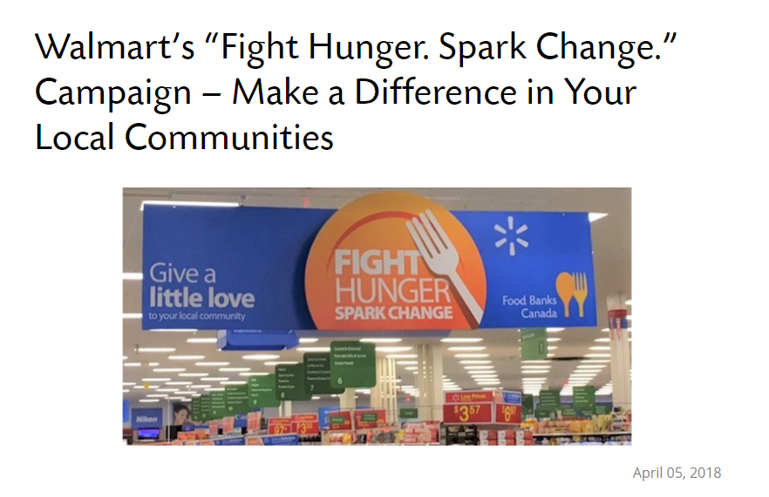

## Problem Statement

Goal of our project is to make process of gathering fund easier and more comfortable. Our project will serve a golden opportunity to the donors to help the needy people of the society. It is combining good work of the donors with the society. Going to physical donation center will be time consuming which will overcome by this project.

## Project Scope

* There are similar projects in the market serving same purpose but there are limitations such as minimum amount of fund that should be made. We will be no restriction on amount of donation. Our project is simple where anyone in interest of donation can use it without any limitation.
* Our project will provide opportunities users to donate their funds, learn about fund raising criteria in which they can donate. It is nonprofit organization which will do all in benefits of the society.
* Here we will provide user to maintain their history of donation and maintain their profile. If user want to donate their money they should register to the website and give their information.
* User can do online payment by credit card or debit card. There will be security for their transaction.
* Another facility we can provide to user is physical donation centers near them to which they can go physically and donate.
* One thing which we are not able to do is promotions on social media.
* We are not able to send notifications user by mobile for their donations.

## High-Level Requirements

* We are providing feature of user-friendly application, where donors do not need to sign up or login to access the website. They can easily see all the information related to website.
* Besides than the inbuilt .NET database we will provide compatibility with SQL Database too.
* We will provide facility to revert. If donors want to revert their donation our website will allow to do that and revert it back.

## Project Team

**Alisha Patel** – As an individual I would like to learn designing and data manipulation using ASP.NET framework. As I had completed my previous course in security, I would like to perform some security aspect to our website such as Cross Site Scripting, post method rather than get. I would like to learn more features related to networking and designing from my partners. I always like to do requirement gathering and analysis activities. As a fresher I do not have any experience related to coding and testing. I would like to learn more and more about that.

**Paras Akbari-** Whilst exploring more and more concepts during my Bachelor of Computer engineering, I became attracted towards two fields programming and designing. I designed and programmed two main projects during my last semester of bachelors first one was an android magazine application and a website regarding information and basics of AI. I would love to learn performance testing and increase performance of any website without compromising design.

**Prit Patel**-My carrier started exploring how to develop the application using asp, java, visual Basics and during that time I developed the project as a "tool Management system" after I decided to travel to Canada to discover further in the IT sector I started networking and now I'm exploring testing skills. Love designing the application and website, and then checking it for myself